Numerical Analysis

Homework 4

Name:朱倩雯 Student ID：56716616

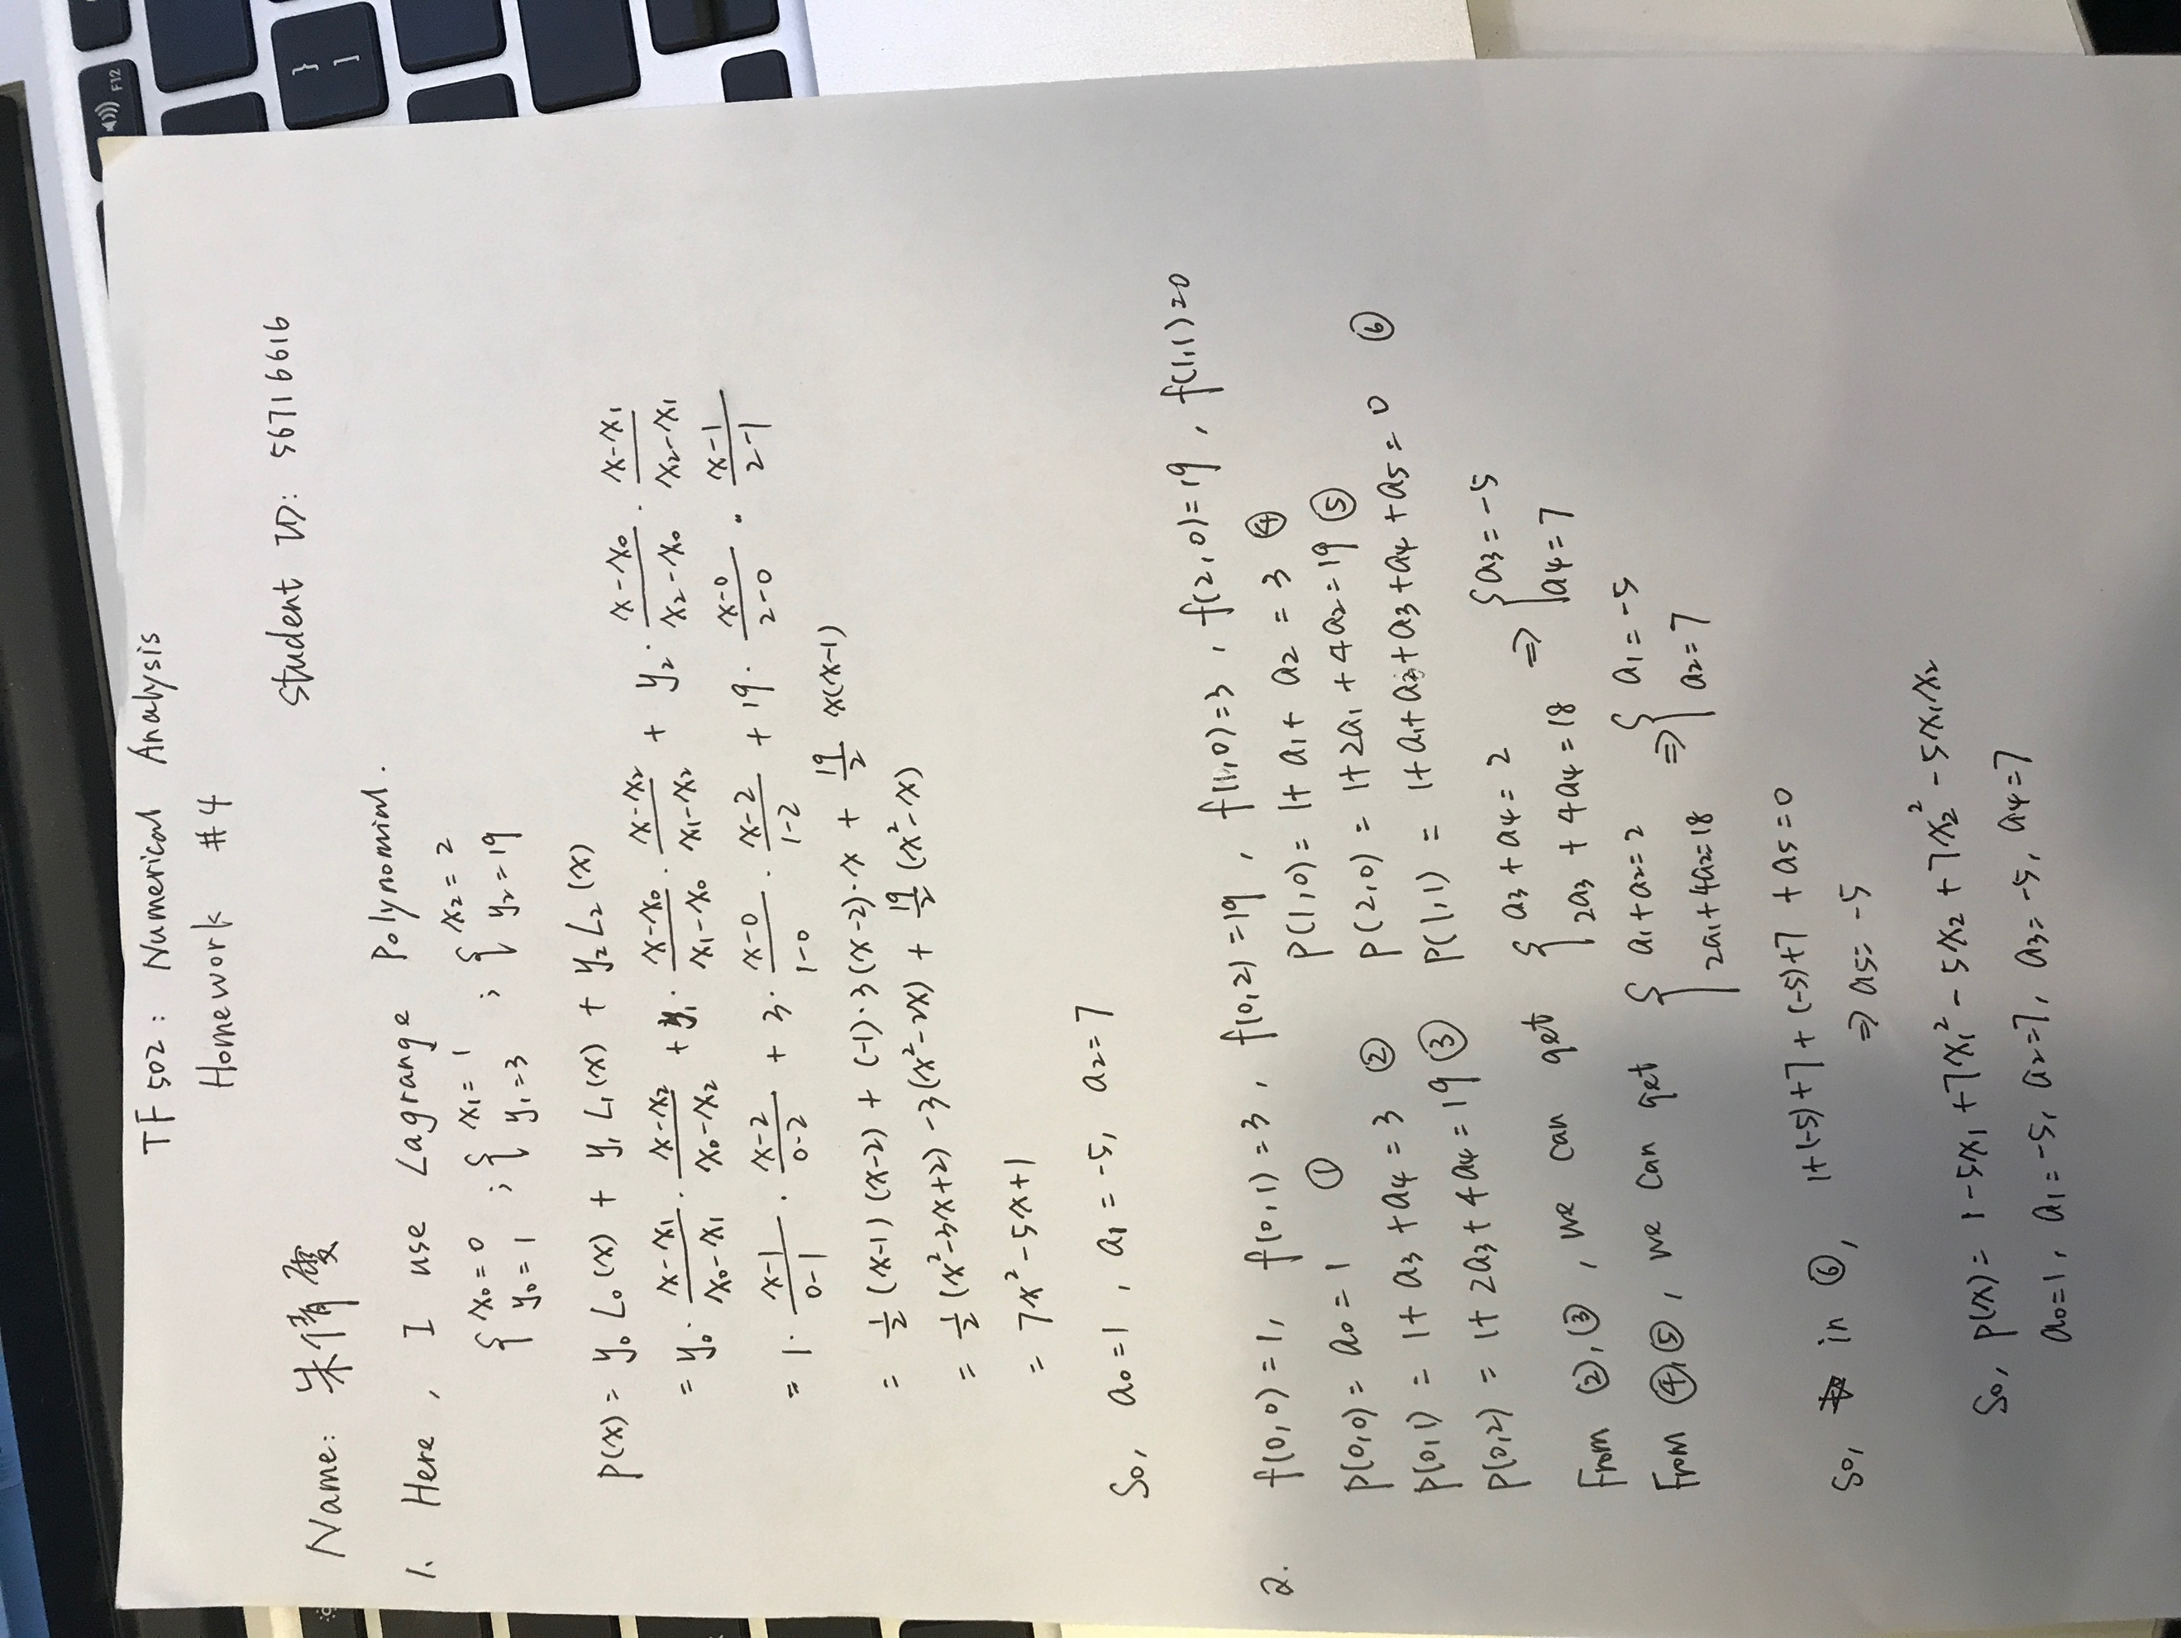

Problem 3

1. Matlab code:

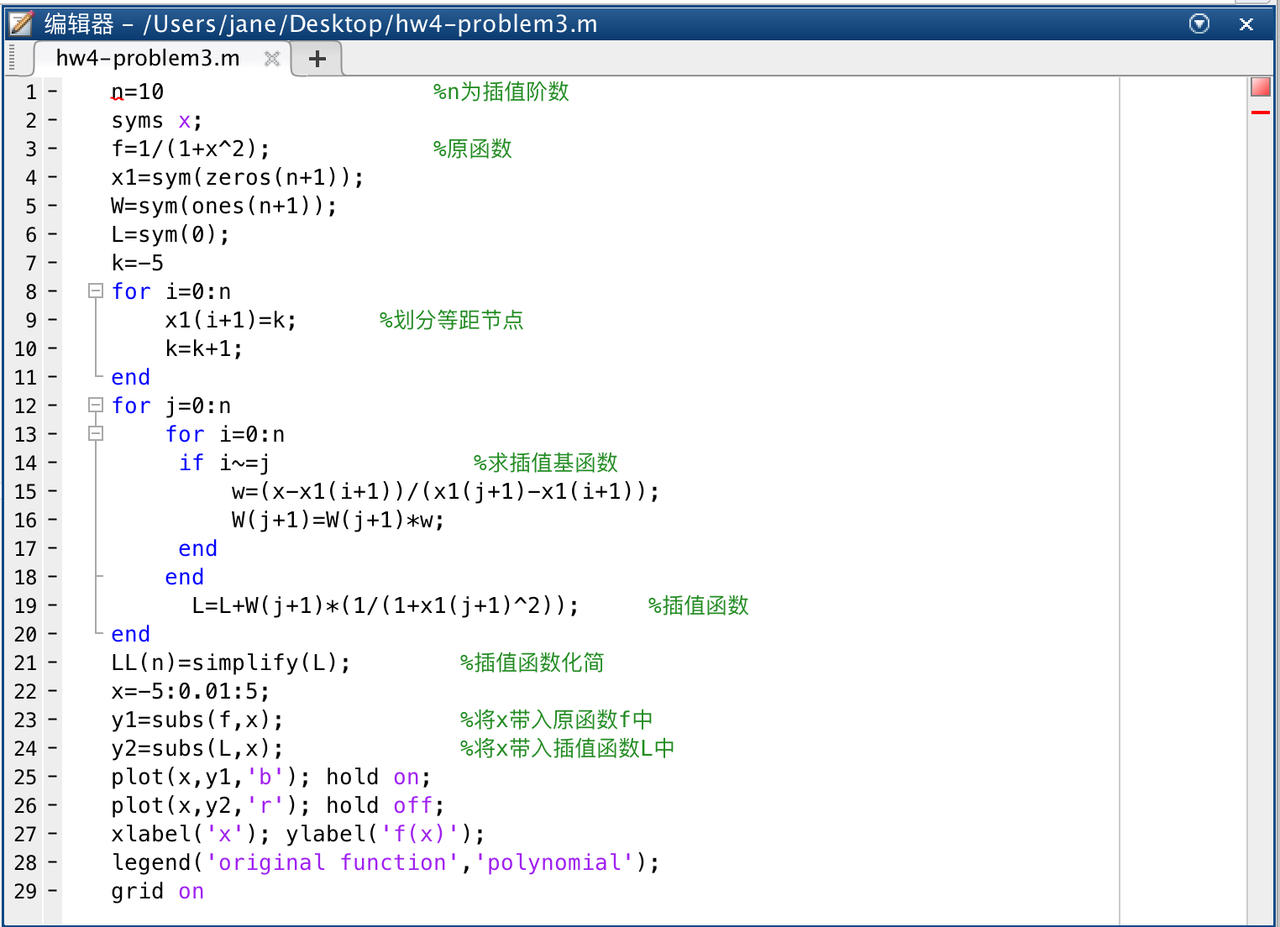

Running Result:

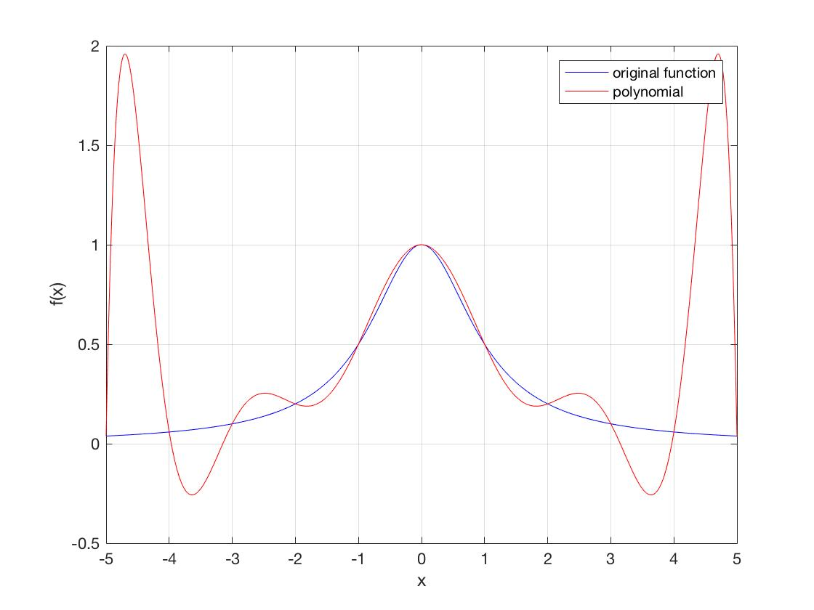

From the above running result, we can find that polynomial p(x) does not approximate f(x) well.

The above figure shows that:

1. f(x) and p(x) are nearly perfect match in the interval [-2,2].
2. f(x) and p(x) are both even function,
3. In the interval except [-2,2],there is an obvious fluctuation between f(x) and g(x).

Problem 4

Matlab code:

Attached to the mail file.

Matlab test code:

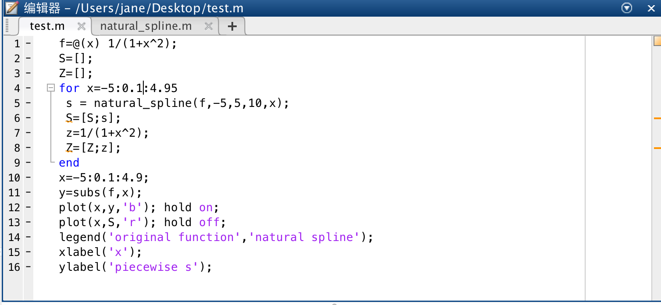

Running result：

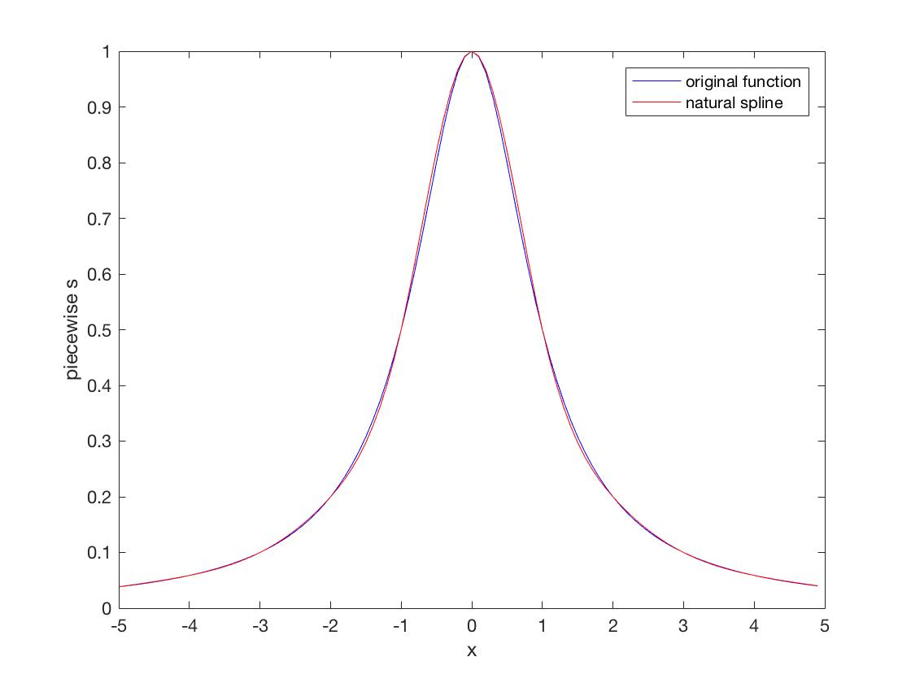

Problem 5:

Matlab code:

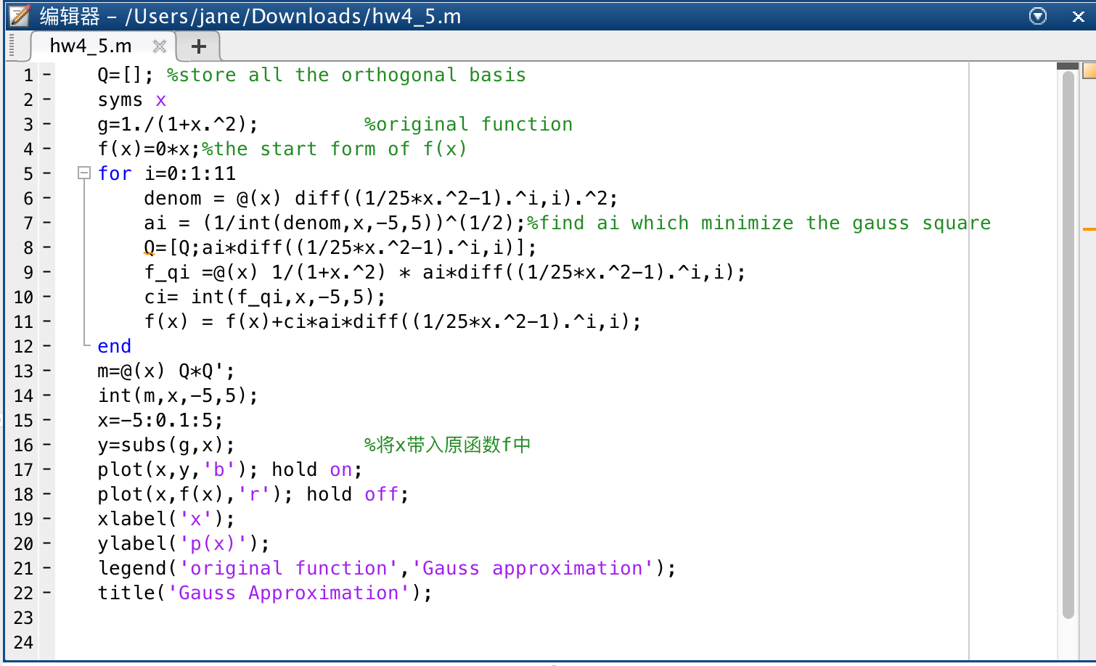

Running result:

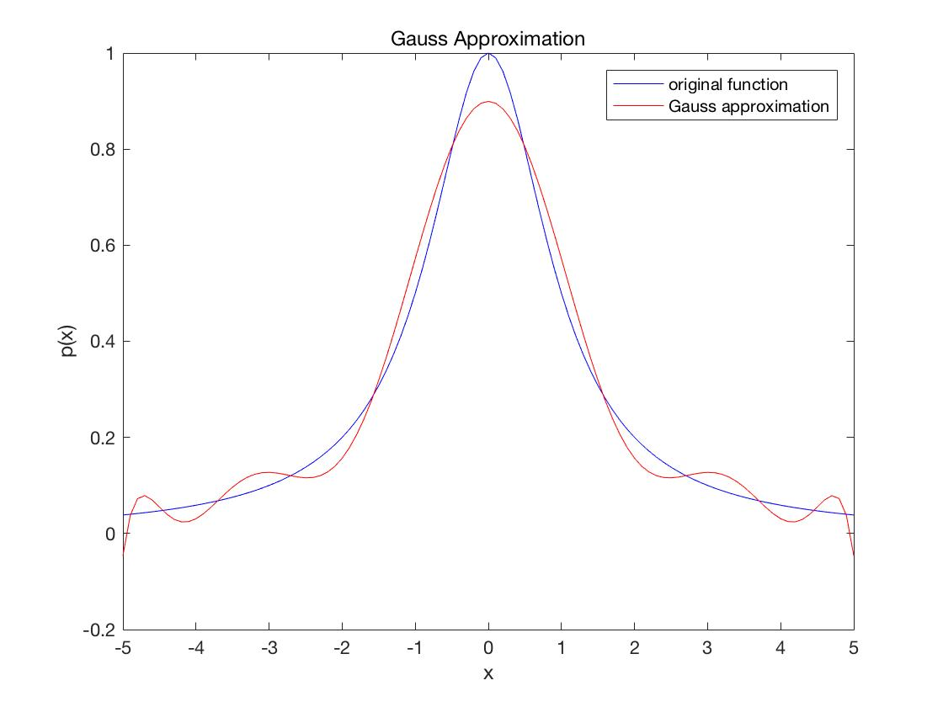

Problem 6: